Order Of Service

Singing: Psalm 22—CW page 71

Reading: Psalm 105:37-45

Opening Hymn: CW 260

Reading: Acts 22:17-21

Request Hymn: CW Supplement 748

Reading: Matthew 9:35-38

Sermon Hymn: CW 256

Sermon Text: Mark 9:14-29

Fire And Waters

Prayer

The Apostles’ Creed, TLH page 12

Holy Communion

The Lord's Prayer

The Blessing

Closing Hymn: CW 449

* * * * * * * * * * *

Koinonia Hour
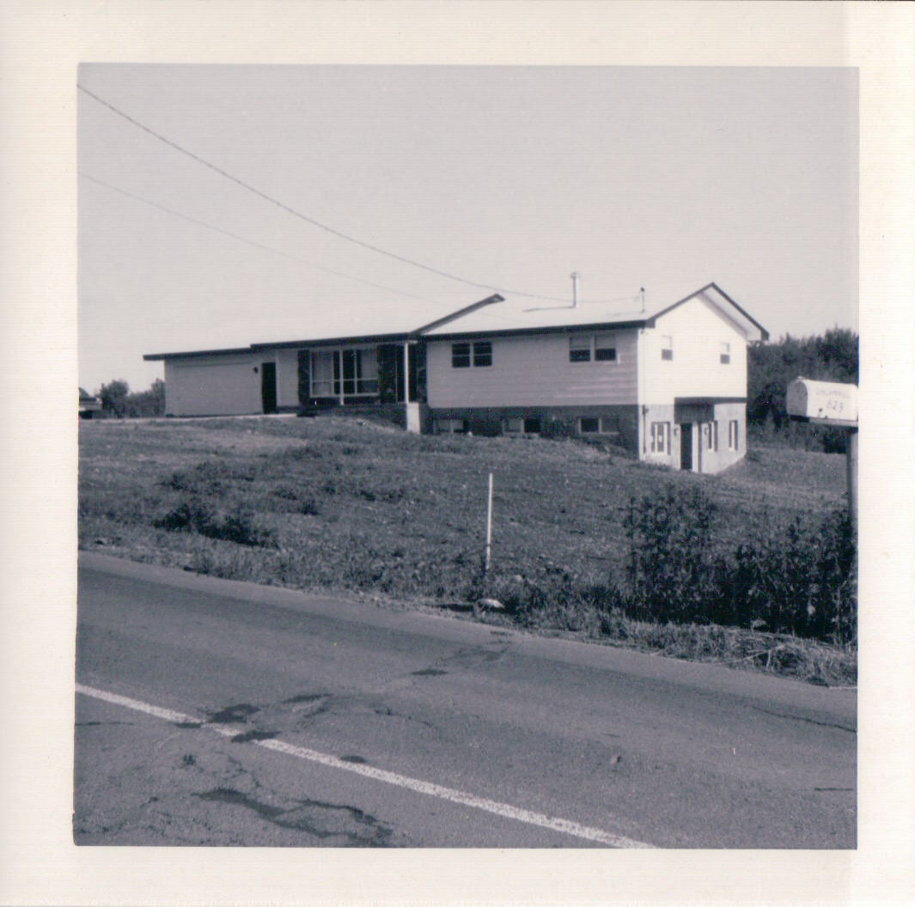

Parsonage-Chapel, Duluth, MN

Water
Of
Life

1 September 2019

W A T E R O F L I F E

Independent Christian Church—Conservative Lutheran Doctrine

Worship Service: 9:30 a.m. Bible Study: 10:45 a.m.

Larry Cooper, Pastor E-Mail address:
111 N. Ridge Road lcooper@wateroflife.cc
Coon Valley, WI 54623 Web Site:
www.wateroflife.cc

* * * * * * * * * * * * * * * * * * * * * * * * * * *

Sermon Text: Mark 9:14-29

Fire And Waters

* * * * * * * * * * * * * * * * * * * * * * * * * * *

Mark 9:14 And when he came to his disciples, he saw a great multitude about them, and the scribes questioning with them.
:15 And straightway all the people, when they beheld him, were greatly amazed, and running to him saluted him.
:16 And he asked the scribes, What question ye with them?
:17 And one of the multitude answered and said, Master, I have brought unto thee my son, which hath a dumb spirit;
:18 And wheresoever he taketh him, he teareth him: and he foameth, and gnasheth with his teeth, and pineth away: and I spake to thy disciples that they should cast him out; and they could not.
:19 He answereth him, and saith, O faithless generation, how long shall I be with you? how long shall I suffer you? bring him unto me.
:20 And they brought him unto him: and when he saw him, straightway the spirit tare him; and he fell on the ground, and wallowed foaming.
:21 And he asked his father, How long is it ago since this came unto him? And he said, Of a child.
:22 And ofttimes it hath cast him into the fire, and into the waters, to destroy him: but if thou canst do any thing, have compassion on us, and help us.
:23 Jesus said unto him, If thou canst believe, all things are possible to him that believeth.
:24 And straightway the father of the child cried out, and said with tears, Lord, I believe; help thou mine unbelief.
:25 When Jesus saw that the people came running together, he rebuked the foul spirit, saying unto him, Thou dumb and deaf spirit, I charge thee, come out of him, and enter no more into him.
:26 And the spirit cried, and rent him sore, and came out of him: and he was as one dead; insomuch that many said, He is dead.
:27 But Jesus took him by the hand, and lifted him up; and he arose.
:28 And when he was come into the house, his disciples asked him privately, Why could not we cast him out?
:29 And he said unto them, This kind can come forth by nothing, but by prayer and fasting.

